Name_________________________
Period_____________
ECOLOGY UNIT
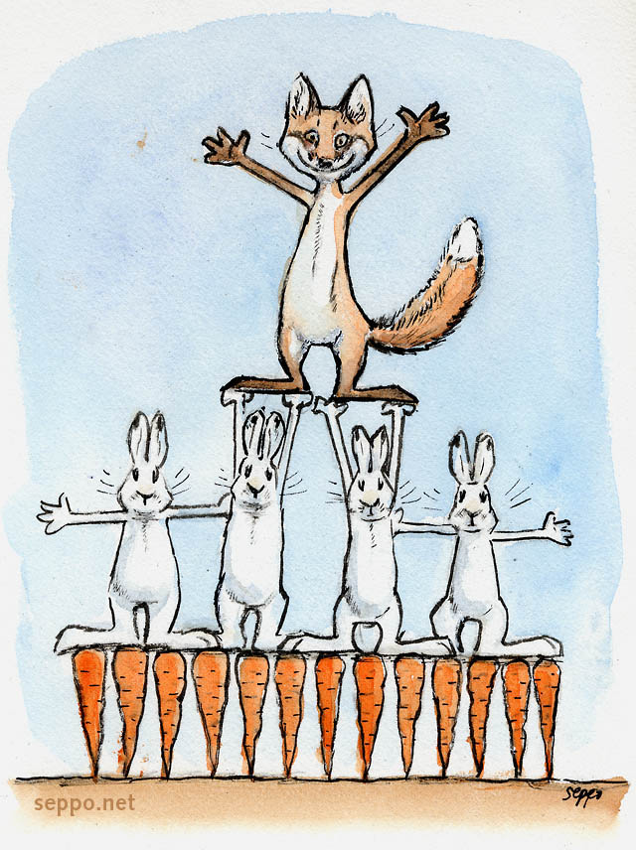
Standard 1: Students will understand that living organisms interact with one another and their environment.

